**Section01 Introduction to Angular**

**Notes:-**

**1-angular give us very reactive experience by provide single html page with inject component inside it (SPA)**

**2-Angular 2 is totally different from Angular 1 (Angular JS) , and its released in 2016**

**(New version every 6 months, only small, incremental, backwards, compatible changes)**

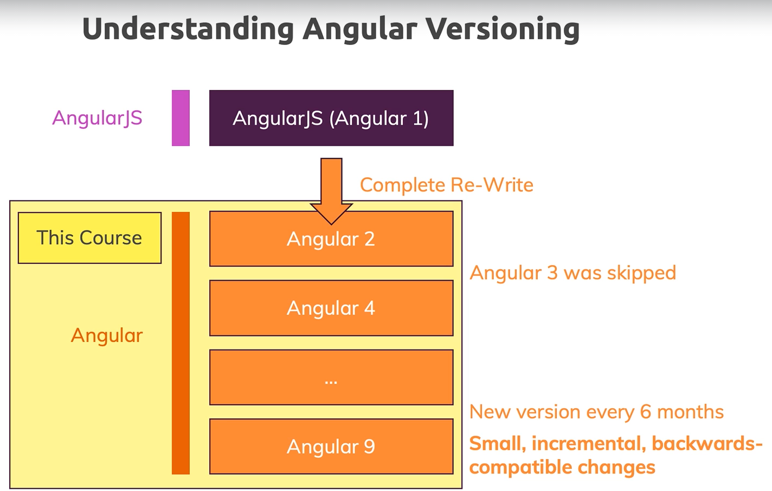

**3-in order to update you environment**

**A-uninstall and reinstall the latest version of node JS**

**Node --version**

**B-on npm update run the below command (to install and manage packages)**

**npm install -g npm //to update the npm to latest version**

**npm --version**

**C-to update the Angular CLI (needed to create angular project)**

**npm uninstall -g angular-cli @angular/cli //to uninstall the angular CLI**

**npm cache verify //to confirm the cache read the new changes**

**npm install -g @angular/cli //to install the latest version**

**Lesson01 Creating new Angular Project**

**Notes:-**

**1-node js is server side platform that use npm (node package manager) to manage our packages**

**ng new my-app**

**cd my-app**

**ng s**

**Example:-**

**We will apply two way binding in angular page by inject form module as below**

**<input type="text" [(ngModel)]="name">**

**<p>{{name}}</p>**

**import { Component } from '@angular/core';**

**@Component({**

**selector: 'app-root',**

**templateUrl: './app.component.html',**

**styleUrls: ['./app.component.css']})**

**export class AppComponent {**

**title = 'my-app';**

**name = "Ali Ahmad";}**

**import { NgModule } from '@angular/core';**

**import { BrowserModule } from '@angular/platform-browser';**

**import { AppComponent } from './app.component';**

**//we inject FormsModule to apply the two way binding [(ngModel)]**

**import { FormsModule } from '@angular/forms';**

**@NgModule({**

**declarations: [AppComponent],**

**imports: [**

**BrowserModule,**

**FormsModule],**

**providers: [],**

**bootstrap: [AppComponent]})**

**export class AppModule { }**

**Lesson02 Course Structure**

**Notes:-**

**1-Databindig is part of built in directive to communicate with the DOM elements**

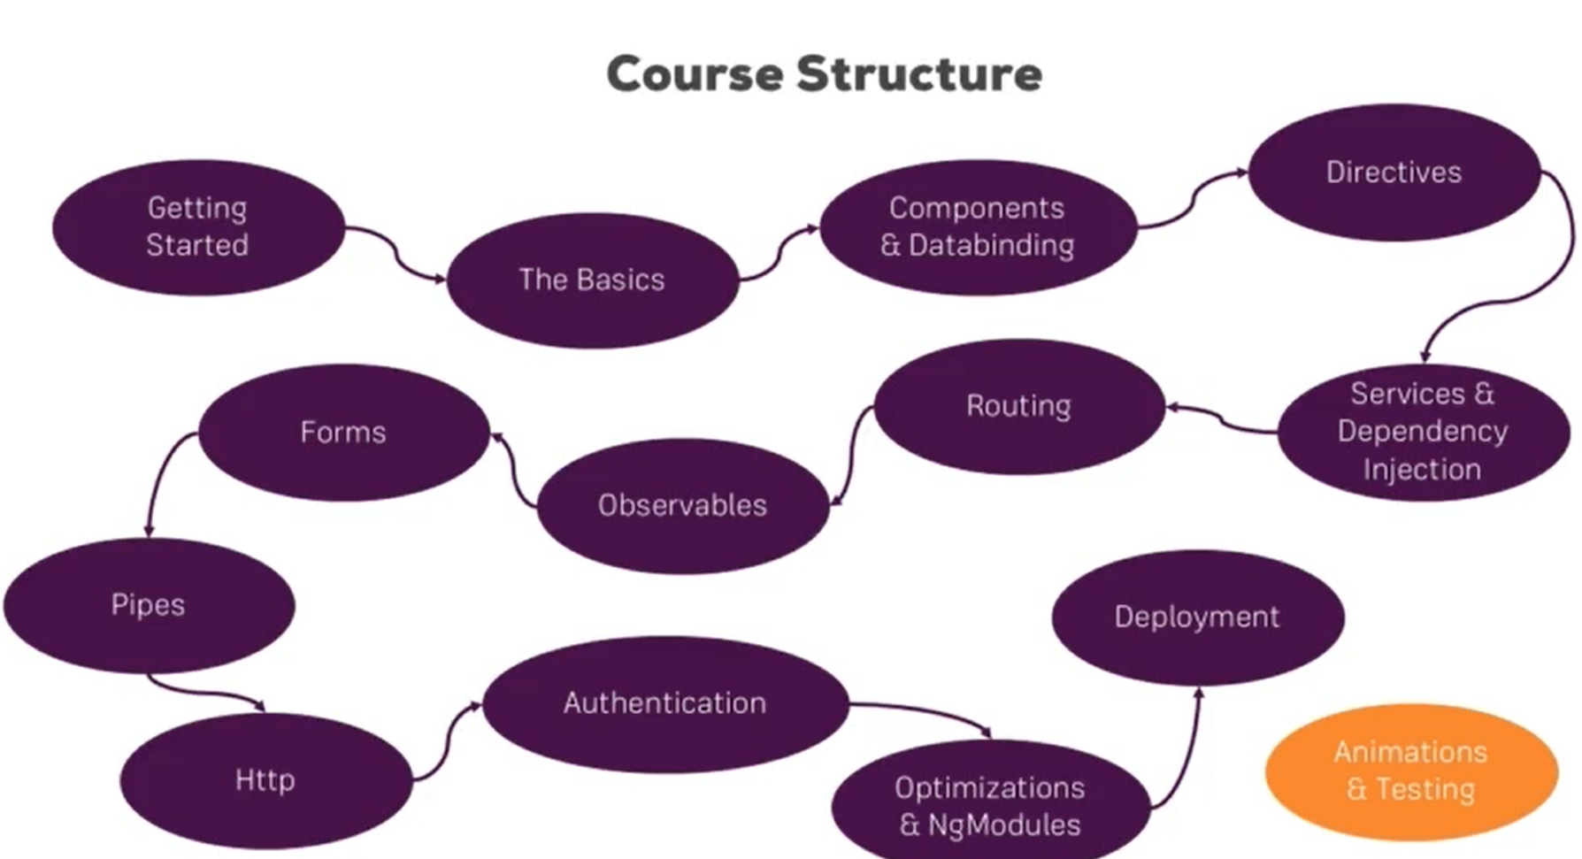

**Lesson03 What is Typescript**

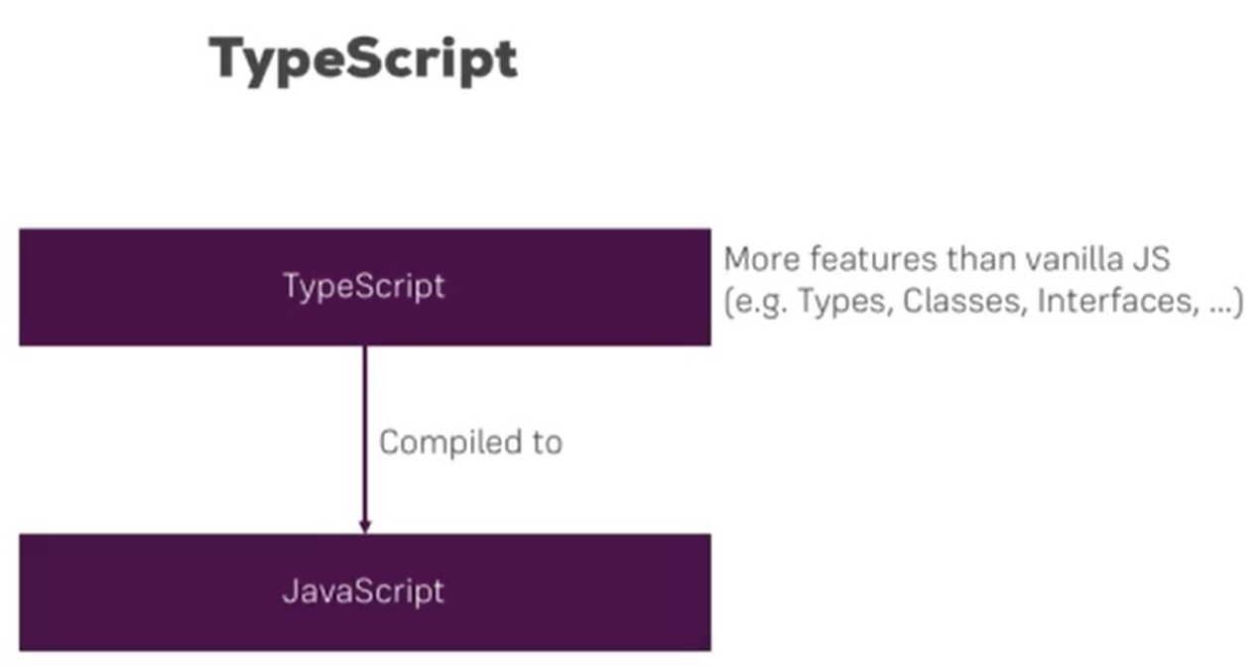

**Lesson04 Basic Project Setup using Bootstrap for styling**

**Notes:-**

**//install bootstrap version 3 locally on the machine as below**

**npm install --save bootstrap@3**

**2-on the angular.json > styles we add the path for the bootstrap.min.css as below**

**"styles": [**

**"src/styles.css",**

**"node_modules/bootstrap/dist/css/bootstrap.min.css"]**

**3-to check that bootstrap.min.css are used on the Developer Tools > Sources > styles.css (you will see that bootstrap v3.4.1 are used as below)**

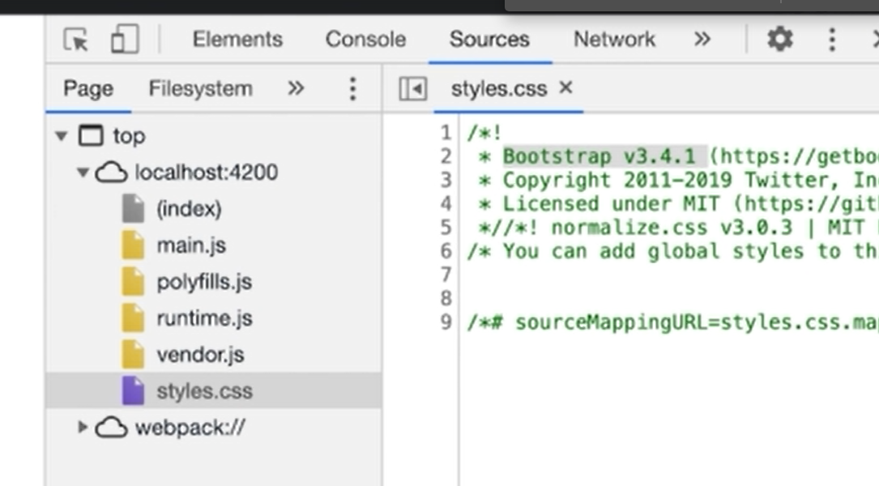

**4-Strict mode forces you to write more verbose code in some places (especially when it comes to class properties). If you enabled it by accident, you can also disable it by setting strict: false in your tsconfig.json file.**